HostsPro

Gage Price

CST-452 Capstone Project Proposal

Grand Canyon University

Instructor: Professor Mark Reha

Revision: 2.0

Date: 03/12/2025

**ABSTRACT**

This project is an application to organize the Microsoft host’s file. The hosts file in the file explorer is a normal text file which contains host names and their corresponding IP addresses. With this file you can override DNS for defined domains on a computer. This file has little structure, the constraints for entries is limited to one line per entry, spaces sperate the domain name and IP address, and comments are created using the pound symbol. The task for this project is to create an application that provides a simple and clean user interface for the user. The user will be able to enter their desired name server and their specified host name. My program will run a background search for the IP address of the name server provided. The program will then use that IP address and note where it points to by storing a comment of the name sever entered. They can activate or deactivate an entry with a click of a button.

For the average person this file is never used, but for some developers this file is used a lot in testing. Others use this file to block websites and set restrictions on what website a device can access. This file editor interface will make their work a whole lot easier, simpler, cleaner, and more organized.

|  |
| --- |
| History and Signoff Sheet |

**Change Record**

|  |  |  |
| --- | --- | --- |
| **Date** | **Author** | **Revision Notes** |
| 09/11/2024 | Gage Price | Initial draft for review/discussion |
| 3/12/2025 | Gage Price | Updates from development changes |
|  |  |  |

|  |
| --- |
| **Overall Instructor Feedback/Comments** |

|  |
| --- |
| **Overall Instructor Feedback/Comments** |

**Integrated Instructor Feedback into Project Documentation**

Yes  No

**Project Approval**

Professor Mark Reha

**TABLE OF CONTENTS**

Project Overview and Project Objectives 4

Project Scope 5

Project Success Measures 6

Project High-Level Solution 7

Project Controls 8

Appendix A – References 11

Appendix B – Copyright Compliance 12

Project Overview and Project Objectives

**State the Problem and Background**

The hosts file is used to customize the IP destination for domain names. It is a very useful tool but with one problem, the file is just an empty text file, and it is up to the user to make sure they edit it correctly. It is simple and straightforward, but it is easy to become disorganized. And what if a user forgets to make a comment on what real domain name is for the IP address they specified? They would have to do a command line search for the domain name. This makes things complicated, sloppy, and inefficient.

Our solution is to create an application that will provide an easy-to-use interface that organizes this process for you. When you record an entry, these command line lookups are done in the background and kept as notes on the entry to make it easy to remember what each entry does. This application will save a lot of time for developers who are constantly making changes to their hosts file and have many entries.

**Project Objectives**

The objective for this project is for the team to create an easy-to-use user interface that a user can leverage to edit their hosts file entries. When run, the application will be able to read and write to the file with admin permissions given by the user. There will be an organized list of existing entries, a way to edit those entries, delete entries, and create new ones. The application will also do lookups in the background for IP addresses, so the user doesn’t have to. And finally, the application is going to be visually appealing.

**Challenges**

The main challenge in creating this application is that the team has no prior experience using Windows Presentation Foundation (WPF), which is going to be used for developing this application. The team has used similar technologies so understanding and developing concepts are there to help guide the team in the development processes of using a new framework.

**Benefits and Opportunities**

The benefits that come with this application are an easier and more organized file. Because of this, developers and even average computer users will save a lot of time. Having some processes automated and creating a clean structure and design will mean users won’t have to spend as much time editing their files, and more time doing more productive work.

Project Scope

1. The following in scope feature is what is going to be included in this project. At the end of development, the application should have all these functionalities. The out-of-scope functionalities are a possible functionality that will not be implemented in this project’s first release.

In Scope:

* Create new entries
* Delete entries
* Edit old entries
* Automate name server lookup
* Set active/inactive entries with a check box
* Ask user for admin permission
* Data validation

Out of Scope:

* Creating a backup hosts file
* IPv6 entries

1. Below is a table of all the stakeholders in the project.

|  |  |  |
| --- | --- | --- |
| Stakeholder Name | Role(s) | Responsibilities |
| Gage Price | Developer | Plan, build, and test the application. |
|  |  |  |

1. Below is a list of the project’s breakdown structure, from 09/04/2024 to 04/27/2025. This table describes what will be created and when, how long it will be worked on, and what is required to start the project (dependencies). This table will be updated as tasks are completed.

|  |  |  |  |  |  |  |  |  |  |  |
| --- | --- | --- | --- | --- | --- | --- | --- | --- | --- | --- |
| Work Breakdown Structure | | | | | | | | | | |
| ID | Task | Dependencies | Status | Effort Hours | Cost | Start Date | Planned Completion | Estimate to Completion | Actual Completion | Resource |
| 1 | Initial meeting with client | N/A | Complete | 2 |  | 09/02/2024 | 09/02/2024 | 100% | 09/02/2024 | Gage |
| 2 | Planning and proposal creation | Task 1 Complete | Complete | 6 |  | 09/04/2024 | 09/22/2024 | 100% | 09/20/2024 | Gage |
| 3 | Research technologies (WPF) | Task 1 Complete | Complete | 10 |  | 09/04/2024 | 10/13/2024 | 100% | 10/10/2024 | Gage |
| 4 | Analyze possible requirements and design | Task 2 Complete | Complete | 10 |  | 09/23/2024 | 10/13/2024 | 100% | 10/18/2024 | Gage |
| 5 | Finalize requirement and design documentation | Task 4 Complete | Complete | 8 |  | 10/13/2024 | 11/17/2024 | 100% | 11/17/2024 | Gage |
| 6 | Begin Development | Task 5 Complete | Complete | 15 |  | 11/17/2024 | 12/15/2024 | 100% | 11/17/2024 | Gage |
| 7 | Code development / Testing | Task 4 Complete | Complete | 15 |  | 01/06/2025 | 03/30/2025 | 100% | 02/16/2025 | Gage |
| 8 | Final Project Complete | Task 7 Complete | Complete | 8 |  | 03/30/2025 | 04/27/2025 | 100% | 03/01/2025 | Gage |
| 9 | Final Presentation | Task 8 Complete | Complete | 5 |  | 04/20/2025 | 04/27/2025 | 100% | 03/13/2025 | Gage |

Project Success Measures

1. The measures that will be used to calculate project success are that we deliver a working product, on-time, and on budget. The working project will have every functionality outlined in the project overview and scope.
2. The following table is a list of project success measure that will be completed if the project is successful.

|  |
| --- |
| Project Completion Criteria |
| 1 – Satisfied customer |
| 2 – Releases on time |
| 3 – All functionalities defined in this proposal are working |

1. Below is a list of assumptions and constraints for the project. Assumptions are conditioning the team believes to be true, while constraints are limiting conditions that could restrict project execution.

|  |  |  |  |  |  |
| --- | --- | --- | --- | --- | --- |
| Assumptions and Constraints | | | | | |
| ID | Description | Comments | Type | Status | Date Entered |
| 1 | This project shouldn’t cost anything, so the budget will be $0. | We don’t believe we will have to use any third-party software when developing my application. | Assumption | Pending | 9/16/2024 |
| 2 | The team might be taking part two of this class online in the spring, narrowing down the time we must build and test the application. | Narrowing down the time requirement after planning could affect project success. | Constraint | Pending | 9/16/2024 |

Project High-Level Solution

**Introduction**

The objective of this application is to create an easier and cleaner way to edit a system’s hosts.exe file.

The hosts file has no error checking or functionalities to assist the user, so it can be a laborious and error-prone process to edit. The default hosts file example can be seen in figure 1.0. In the example section you see two example entries with an IP address, a few spaces, a domain name, and finally a comment. This structure is not enforced and the text file hard to read. 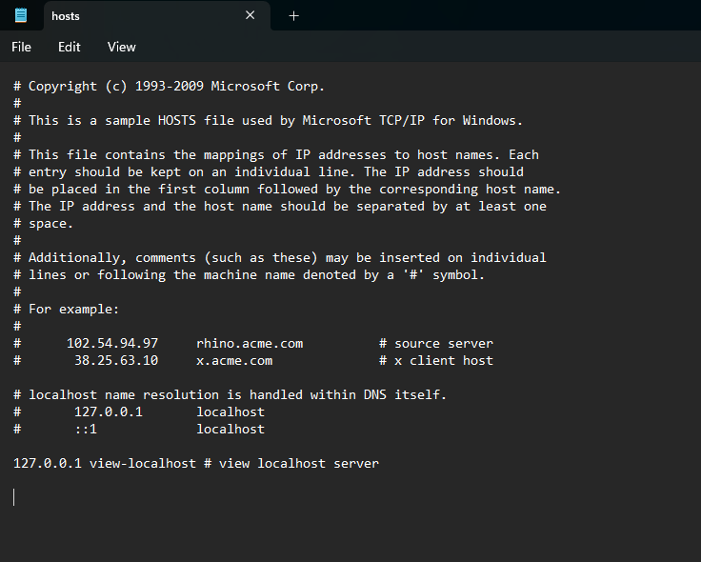

Figure .0

The client has made it clear that their main problem with this structure is that adding and deleting records is time consuming, and they don’t like having to look up the IP address for their desired location. The solution to this is to create an interface that makes all of these operations easier and some even automated.

**Solution**

The solution to the client’s problem is to create a user-friendly application that can be ran on their local machine to update the hosts.exe file. Figure 2.0 displays a high-level diagram of the solution proposed.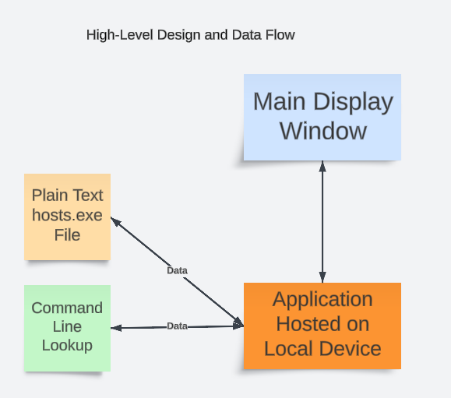

Figure .0

This application will run independently on a machine, meaning the logic and data will only travel throughout the local machine. The application’s backend logic will be the center of the application, communicating between the application’s interface and the hosts file itself. As a user interacts with the interface, the application will be reading and writing information from the hosts text file. Data displayed to the user will come from the text file, and information written by the user will be written to the file. Also, as a user enters server names, the application will simultaneously run command line lookups in the background. If an IP address can be found it will be displayed to the user and written to the text file. If not, it will notify the user. The application will be developed in the Windows Presentation Foundation (WPF) development framework. This C# framework supports quick rendering and robust data binding, which will be needed to create a satisfactory application that will solve this particular problem. With the proposed solution the client would have a much easier time working with their hosts file, eliminating a tedious task and improving productivity.

Project Controls

1. The following tables outlines current and potential risks, as well as current issues. Risks are defined as possible problems and issues are risks that have escalated. Currently there are no issues, but there is a small risk related to the technologies being used in this project. Steps are being taken to minimize that risk.

|  |  |  |  |  |
| --- | --- | --- | --- | --- |
| Risk Management | | | | |
|  | **Risk Probability** | **Risk Impact** |  |  |
| **Event Risk** | **(high, medium, low)** | **Risk Mitigation** | **Contingency Plan** |
| The developers can’t learn XAML in time. | 15% | The project will get pushed out. | Research XAML usage and syntax. | Possibly migrate to a different technology. |

|  |  |  |  |  |  |  |  |  |
| --- | --- | --- | --- | --- | --- | --- | --- | --- |
| Issues Log | | | | | | | | |
| **ID** | **Description** | **Project Impact** | **Action Plan/Resolution** | **Owner** | **Importance** | **Date Entered** | **Date to Review** | **Date Resolved** |
| 1 |  |  |  |  |  |  |  |  |
| 2 |  |  |  |  |  |  |  |  |
| 3 |  |  |  |  |  |  |  |  |

1. The following change control log is to keep track of future changes to the project. As of now, there have been no changes.

|  |  |  |  |  |  |  |  |  |  |
| --- | --- | --- | --- | --- | --- | --- | --- | --- | --- |
| Change Control Log | | | | | | | | | |
| **ID** | **Change Description** | **Priority** | **Originator** | **Date Entered** | **Date Assigned** | **Evaluator** | **Status** | **Date of Decision** | **Included in Rev. #** |
| 1 |  |  |  |  |  |  |  |  |  |

Appendix A – References

*N/A*

Appendix B – Copyright Compliance

N/A